# Analysis and Findings – Big Mountain Resort Ticket Pricing Analysis

In support of assessing Big Mountain Resorts ticket pricing relative to the other market players, a thorough analysis was executed to identify what opportunities exist to reduce expense or generate more revenue from the mountain assets.

## Conclusions

Based on the analysis performed, the following conclusions are drawn:

1. Relative to the market, Big Mountain Resorts adult weekend ticket price is below market value relative to the US aggregate of resorts. An increase of up to $7.05 appears to be justified based on Big Mountain Resorts asset pool.
2. Reducing the number of runs available to the customers lowers operating expense but does not increase revenue.
3. The proposed change of supports an estimated $0.76 increase per ticket sold, for the 350,000 annual visitors this would account for revenue boost of $1,333,333 for the resort.

## Recommendations

1. Increase the adult ticket price by $4-$6.
2. Consider implementation of Option 2: adding a run, increasing the vertical drop by 150 feet, and installing an additional chair lift. This could lead to a per ticket increase of the $0.76 per ticket. Confirm if revenue offsets operating expenses.
3. Bring forward these finding to the executive steering team for review and consideration.

## Assumptions

* The data contained in the databases is taken from reliable publicly available sources.
* We don’t know whether other resorts are overpriced or underpriced for the market.
* 350,000 annual visitors who stay for 5 daily ski sessions each.

## Details

At the time of this initiative, Big Mountain Resort charges a flat fee of $81 for Adult ski passes (weekend and weekday). Based on the Random Forest model implemented, the most important features contributing to price are Number of Fast Quads, Runs, Snow Making Coverage, and vertical drop, see Figure 1.

Big Mountain Scores high in the population on the important metrics (Figure 2), which gives indication that there is opportunity to increase the ticket price. Based on the model prediction, the price could be increased to as much as $88.05 if one subtracts the Mean Absolute Error of from the result. Furthermore, if Option 2 of the strategy options were to be taken, an additional $0.76 could be added to this price. Packaging the increase with a new feature such as option 2 could be a way to mitigate perception of a price hike.

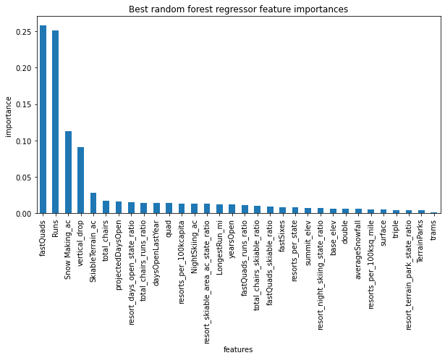

Figure 1: Feature Importance

### Where does Big Mountain stack up against the competition?

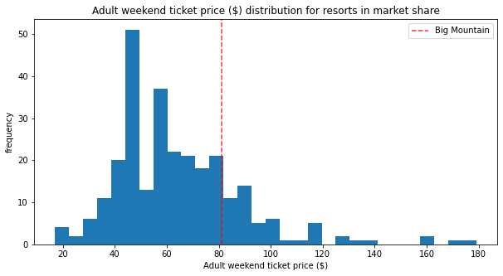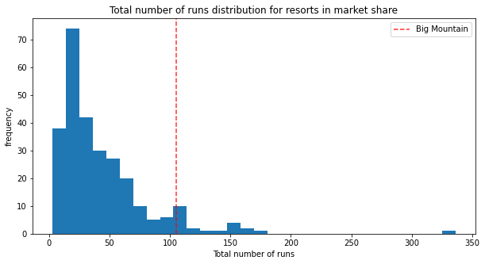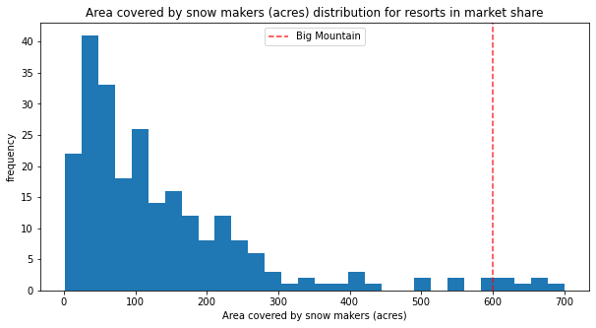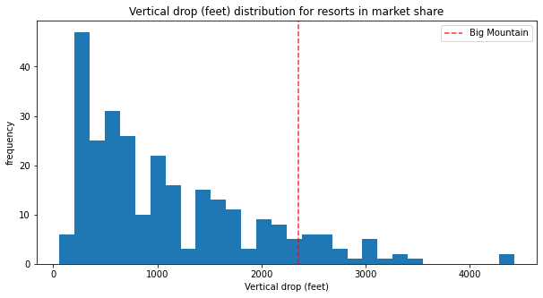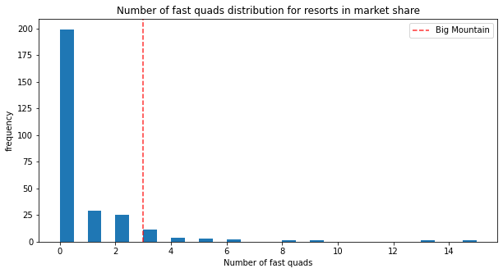

Figure 2: Distribution of top features